A System Dynamics Model of the Refugee Crisis
Part 3 - Stock and Flow Diagrams
Reading Stock and Flow Diagrams
In this section, the basic elements of the System Dynamics computer simulation are described. The computer simulation model is described as a sequence of interrelated sub-models. For each sub-model, a Stock and Flow diagram is provided using the special-purpose Vensim software package. This software can be used to envision and solve the mathematical system of first-order differential equations. In the diagrams, the state variables (Stocks) are shown as boxes. The flow variables are shown as in-flowing and out-flowing pipes with valves. The valves represent the control of the flows that change over time affecting the state variables. There are usually numerous arrows between the states and the flows and the auxiliary variables that represent the passing of information. The sub-models are inter-connected using shadow variables denoted using "< >" brackets and shown in light grey. These shadow variables are calculated in one of the other sub-models.

As was mentioned in Part 1, System Dynamics modeling requires that the mathematical formulae maintain unit consistency. One trick is often used to ensure this unit consistency, namely "Effect" functions. We can think of one element in the model in some unit of measure affecting another element of the model in some other unit of measure through a non-linear Effect function. These Effect functions require a dimensionless input and usually translate this into a dimensionless output using a non-linear "look-up" function. This dimensionless output is usually used as a multiplier. The Effect function requires another trick to make the input dimensionless. For example, in the model, there is an Effect of Violence on Food Aid. The amount of Violence is measured in ongoing Battles. However, the Effect function does not use the amount of Violence directly as an input because it is a dimensioned variable. Instead, the trick is to use the current amount of Violence divided by a value called the Normal Violence which is also measured in Battles. So, by dividing the current amount of Violence by the Normal amount of Violence, a relative value for the amount of Violence is obtained that is dimensionless. That is, the input is a value that indicates whether the amount of Violence is greater than Normal (i.e. relative value greater than 1.0), less than Normal (i.e. relative value between 1.0 and 0.0) or exactly Normal (i.e. relative value 1.0).

The Look-Up functions that implement these Effect functions are generally non-linear and can take on any desired shape. This is implemented in the software by specifying points on an x-y plot and joining these points by straight lines. The input values are shown on the x-axis and the output values are shown on the y-axis. Linear interpolation is used by the Look-Up function to translate the input value into an output value.

The formulae used in each of the sub-models is described in words below and the actual mathematical formulae are provided in Annex A. The Effect functions are provided in Annex B, and the Initial values of the state variables, the Normal values used in the Effect functions and the other Constants used in the model are provided in Annex C.
The Allocation of Investment Towards the Relief Effort

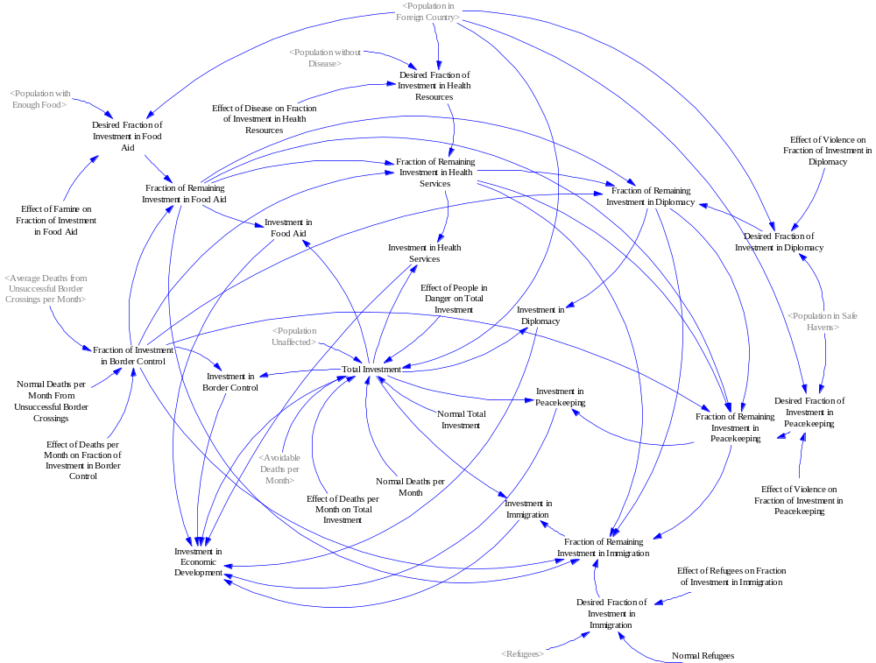
Sub-Model for the Allocation of Investment Towards the Relief Effort

The first sub-model calculates the total amount of investment in relief, in millions of dollars per month, and then allocates that total amount of investment towards the various types of relief, namely, border control, food aid, health services, diplomacy, peacekeeping, immigration services and economic development.

Total Investment per Month
The total amount of relief money per month is based on a normal amount of investment, in million dollars per month, multiplied by the effect of people in danger on total investment and the effect of deaths per month on total investment which are both calculated as dimensionless multipliers. The larger the fraction of the population in danger the greater the total investment and the more deaths per month the more total investment requested.

The effect of people in danger is based on the number of people affected by the crisis divided by the total number of people in the country (i.e. the fraction of the population that is in danger from the crisis). To find the number of people in danger from the crisis, we need to find the number of people affected by famine, disease, violence and poverty. This is done in a slightly backward manner by calculating the number of people in the country unaffected by the crisis and subtracting that from the total population in the country. The number of people unaffected by the crisis is the minimum of the number of people with enough food, the number of people without disease, the number of people in safe havens and the number of people with jobs. Then the fraction of the population in danger is calculated by taking the total population in the country and subtracting the number of people unaffected by the crisis and then dividing that by the total population in the country.

The effect of deaths per month on total investment is based on the number of avoidable deaths per month which is the sum of the average deaths by starvation per month, the average deaths by disease per month, the average deaths by violence per month and the average deaths caused by unsuccessful unconventional border crossings per month. This number of avoidable deaths per month is divided by the normal number of deaths per month.

Investment in Border Control
The first allocation of money is to border control in millions of dollars per month. In this calculation, the fraction of total investment in border control is calculated based on an effect function which uses the average number of deaths caused by unsuccessful unconventional border crossings per month divided by the normal number of deaths per month caused by unsuccessful unconventional border crossings. So, the greater the relative number of deaths per month caused by unsuccessful unconventional border crossings, the larger the fraction of the total investment allocated to border control. This dimensionless fraction is multiplied by the total investment to determine the allocation of investment to border control.

Investment in Food Aid
The second allocation is to food aid in millions of dollars per month. This time, the desired fraction of total investment to food aid is calculated using the effect of famine on food aid. The input to the effect of famine is based fraction of the population without enough food which in turn is based on the total population of the country and the number of people with enough food. The larger the fraction of the population without enough food, the larger the desired fraction of total investment allocated to food aid. The actual fraction of total investment to food aid is the minimum of the desired fraction of investment to food aid and one minus the fraction of investment to border control. Then, the actual fraction of investment to food aid is multiplied by the total investment to determine the allocation of investment to food aid.

Investment in Health Services
The third allocation is to health services in millions of dollars per month. This time, the desired fraction of total investment to health services is calculated using the effect of disease on investment in health services. The input to the effect of disease on investment in health services is based fraction of the population with disease which in turn is based on the total population of the country and the number of people without disease. The larger the fraction of the population with disease, the larger the desired fraction of total investment allocated to health services. The actual fraction of total investment to health services is the minimum of the desired fraction of investment to health services and one minus the sum of the fraction of investment to border control and the fraction of investment to food aid. Then, the actual fraction of investment to health services is multiplied by the total investment to determine the allocation of investment to health services.

Investment in Diplomacy
The allocation of investment to diplomacy is based on the effect of violence. The desired fraction of investment to diplomacy is calculated as the effect of violence on the population which in turn is based on the fraction of the population affected by violence. That is, the total population in the country minus the number of people in safe havens divided by the total population in the country. The larger the fraction of the population at risk of violence, the greater the desired fraction of the total investment allocated to diplomacy. Again, the actual fraction of investment to diplomacy may not be the same as the desired fraction of the investment to diplomacy. The actual fraction of investment in diplomacy is the minimum of the desired fraction of investment to diplomacy and one minus the sum of the fraction of investment to border control, the fraction of investment to food aid and the fraction on investment to health services. The actual fraction of investment to diplomacy is then multiplied by the total investment to obtain the allocation of total investment to diplomacy in millions of dollars per month.

Investment in Peacekeeping
The fifth allocation is to peacekeeping. The desired fraction of total investment to peacekeeping is calculated using the effect of violence on investment in peacekeeping. The input to this effect is the fraction of people affected by violence which is based on the number of people in safe havens and the total population in the country. The total population in the country minus the number of people in safe havens is assumed to be the number of people at risk of violence. By dividing this value by the population in the foreign country, one gets the fraction of the population at risk of violence. The larger the fraction of the population at risk of violence, the larger the desired fraction of total investment allocated to peacekeeping. Then, the actual fraction of total investment to peacekeeping is the minimum of the desired fraction of investment to peacekeeping and one minus the sum of the fraction of total investment to border control, the fraction of total investment to food aid, the fraction of total investment to health services and the fraction of total investment to diplomacy. This actual fraction of investment to peacekeeping is multiplied by the total investment to obtain the investment in peacekeeping in millions of dollars per month.

Investment in Immigration
The allocation of investment to immigration services is based on the relative number of refugees fleeing the country. That is, the number of refugees fleeing the country is divided by the normal number of refugees and input to a function representing the effect of refugees on investment in immigration to obtain the desired fraction of total investment allocated to immigration services. The larger the relative number of refugees, the larger the desired fraction of total investment allocated to immigration. The actual fraction of investment allocated to immigration is the minimum of the desired fraction of investment to immigration and one minus the sum of the fraction of investment to border control, the fraction of investment to food aid, the fraction of investment to health services, the fraction of investment to diplomacy and the fraction of investment to peacekeeping. Then the actual fraction of investment allocated to immigration is multiplied by the total investment to obtain the investment in immigration in millions of dollars per month.

Investment in Economic Development
It is assumed that any remaining relief would be invested in economic development. So, the amount of investment in economic development is simply the total investment minus the sum of the investment in border control, the investment in food aid, the investment in health services, the investment in diplomacy, the investment in peacekeeping and the investment in immigration services.

The Movement of Refugees
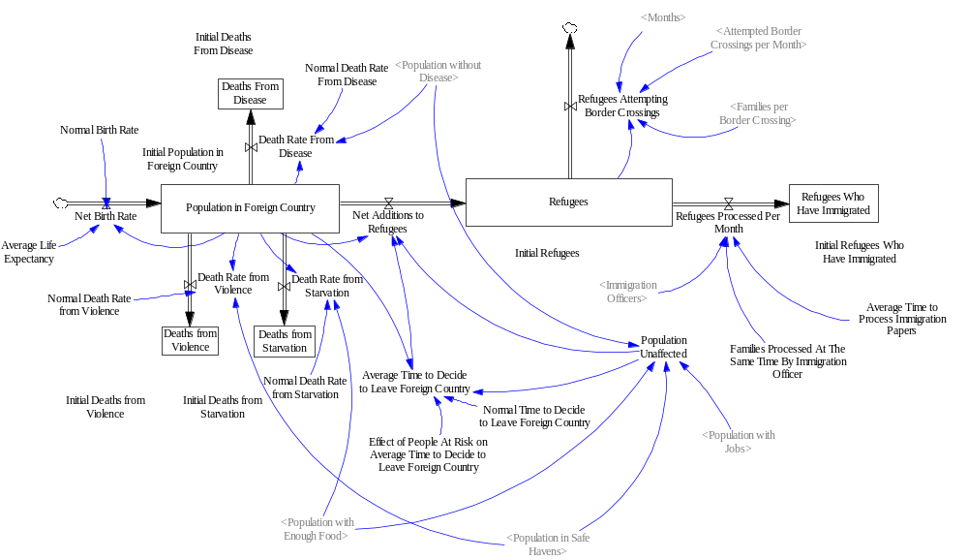
Refugee Movement Sub-Model
Population in Foreign Country
The population in the foreign country is a stock variable, measured in families, as shown by the box in the figure above. This variable is given an initial value at the start of the simulation which represents an estimate of the number of families in the country before the crisis and then the population changes based on the in-flow and the out-flows. There is one flow variable into the stock variable (Net Birth Rate) and four flows out of it (Deaths Rate from Starvation, Deaths Rate from Violence, Deaths Rate from Disease and Net Additions to Refugees).

The net birth rate is the difference between births and deaths from natural causes. The number of births is calculated by multiplying the normal birth rate by the population in the foreign country. The number of deaths is calculated by dividing the population in the foreign country by the average life expectancy.

The death rate from starvation is calculated by multiplying the normal death rate from starvation by the population without enough food. The population without enough food which, in turn, is calculated as the population in the foreign country minus the population with enough food. The greater the population without enough food, the higher the death rate from starvation.

The death rate from violence is calculated by multiplying the normal death rate from violence by population at risk from violence. The population at risk from violence is calculated by subtracting the population in safe havens from the population in the foreign country. The larger the population at risk from violence, the higher the death rate by violence.

The death rate from disease is calculated by multiplying the normal death rate from disease by the population with disease. The population with disease which is calculated by subtracting the population without disease from the population in the foreign country. The larger the population with disease, the higher the death rate by disease.

Refugees will decide to leave the foreign country based on the impact of famine, disease, violence and poverty. The number of refugees deciding to leave the country is based on population affected by the crisis divided by the average time to decide to leave the country. The population affected by the crisis is calculated as the population in the foreign country minus the population unaffected by the crisis. The population unaffected by the crisis is the minimum of four values: the population with enough food, the population without disease, the population in safe havens and the population with jobs. The average time to decide to leave the country is calculated as the normal time to decide to leave the country times the effect of the fraction of people at risk on the time to decide to leave the country. The higher the fraction of people at risk, the lower the average time to decide to leave the country.

Deaths From Starvation
The deaths from starvation is also a stock variable, measured in families, which is initially set to zero and has a single in-flow of the death rate from starvation. The in-flow death rate from starvation is the same as the out-flow from the population in the foreign country described above.

Deaths From Violence
The deaths from violence is a stock variable, measured in families, which is also initially set to zero. It has a single in-flow of the death rate from violence. This in-flow is the same as the out-flow from the population in the foreign country.

Deaths From Disease
The deaths from disease is a stock variable, measured in families, which is also initially set to zero. It has a single in-flow of the death rate from disease. This in-flow is the same as the out-flow from the population in the foreign country.

Refugees
Refugees is a stock variable, measured in families, which is initially set to zero. It has one in-flow (net additions to refugees) and two out-flows (refugees processed per month and refugees attempting unconventional border crossings). The net additions to refugees is an in-flow to refugees that is the same as the out-flow from population in foreign country that was described above.

The refugees processed per month is calculated as the number of immigration officers times the number of families processed at the same time by an immigration officer divided by the average time to process immigration papers The greater the number of immigration officers, the greater the number of refugees processed per month.

The refugees attempting border crossings is calculated as the attempted border crossings per month multiplied by the families per border crossing. The attempted border crossings per month and the families per border crossing are calculated in the unconventional border crossings sub-model which will be described later.

Refugees Who Have Immigrated
The refugees who have immigrated is also a stock variable, measured in families, in which the initial value is set to zero and the single in-flow is the refugees processed per month which is the same as the out-flow from refugees.

The Food Supply
The food supply is a separate sub-model that includes a single stock variable for food, measured in food units which represents the amount of food required for one family for one month. It has two in-flows (food growth and food aid) and two out-flows (food consumption and food export).

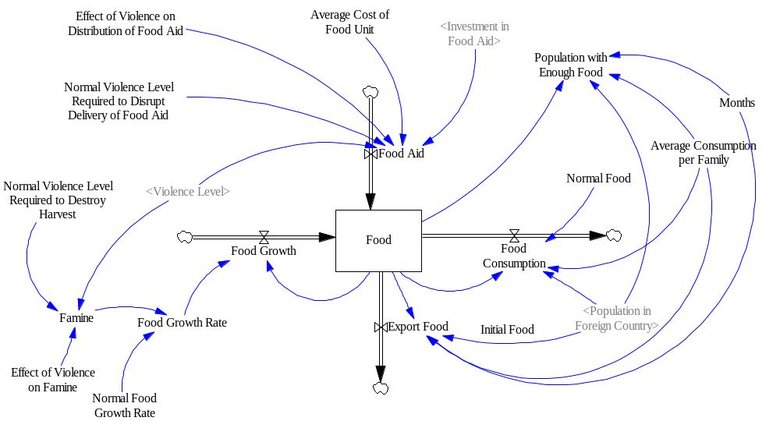
Food Supply Sub-Model
Food growth is calculated by multiplying the food growth rate by the food. The food growth rate is based on the normal food growth rate multiplied by the one minus a value for famine which is a fractional value between zero and one. Famine is calculated based on the effect of violence which uses the current violence level divided by the normal level of violence required to destroy the harvest. The greater the relative violence level, the greater the level of famine.

Food aid is an in-flow which is calculated by multiplying the investment in food aid divided by the average cost of a food unit by the effect of violence on distribution of food aid. The effect of violence is calculated based on the current violence level divided by the normal violence level to disrupt distribution of food aid. Violence will impede the distribution of food aid. So the greater the relative level of violence, the less food aid that is provided.

Food consumption is calculated by dividing the food level by the normal food level and multiplying this by the average consumption per family and the population in the foreign country. Therefore, as the relative level of food declines the average distribution of food to the families will decline.

Food export is calculated as the food level minus the food consumption if this value is greater than zero.

Finally, the population with enough food is calculated as the food level divided by the average consumption of food per family.

Disease
The disease model is primarily focused on the outbreak of cholera in the safe havens. There is an initial number of families effected by a cholera outbreak. There is an in-flow of families being infected with the disease and an out-flow of families being cured of the disease.
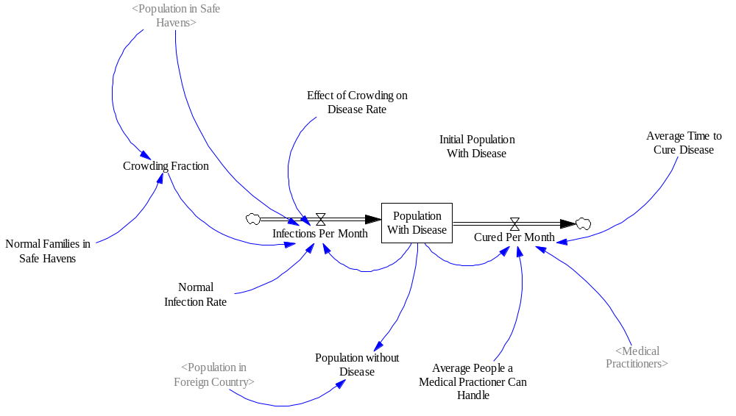
Disease Sub- Model
The in-flow of infections per month is based on the population with disease and the normal infection rate. These are multiplied together and then the effect of crowding comes into play. The effect of crowding on disease rate is a multiplier that is high when there is a large population in the safe havens compared to the capacity of the safe havens and lower when there is smaller population in the safe havens compared to the capacity of the safe havens.

The out-flow of cured families per month is calculated as the number of medical practitioners times the people a medical practitioner can handle divided by the average time to cure the disease.

Then the population without disease is the population in the foreign country minus the population with disease.

The Safe Havens
Safe Havens is a stock variable, measured in havens, which is initially set to a value that ensures that the entire foreign country consists of safe havens based on the average population per safe haven. It has one in-flow (safe havens created) and one out-flow (safe havens destroyed).

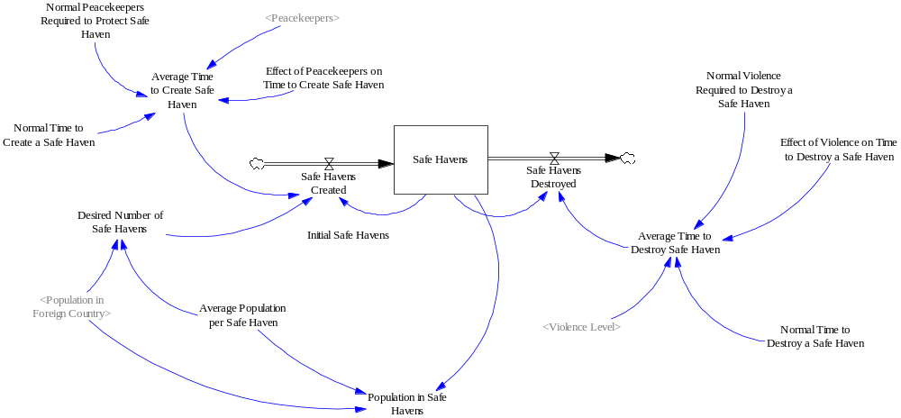
Safe Havens Sub-Model

Safe havens created is calculated by finding the desired number of safe havens which is the population in the foreign country divided by the average population per safe haven. Then the current number of safe havens is subtracted from the desired number of safe havens and divided by the average time to create a safe haven to obtain the safe havens created per month. The average time to create a safe haven is calculated as the normal time to create a safe haven times the effect of peacekeepers on the time to create a safe haven which uses the number of peacekeepers divided by the normal number of peacekeepers.

The safe havens destroyed is calculated as the current number of safe havens divided by the average time to destroy a safe haven. The average time to destroy a safe haven is calculated by multiplying the normal time to destroy a safe haven by the effect of violence on the time to destroy a safe haven where this is based on the current violence level divided by the normal violence level required to destroy a safe haven. The higher the level of violence, the less time it will take to destroy a safe haven.

Violence
Violence, measured in ongoing battles, is set to an initial value of one. Then, it changes based on the net change in violence. The net change in violence is calculated as the desired level violence minus the actual level of violence divided by the average time to change the violence level. The desired level of violence is the current violence level times the violence escalation rate minus the sum of the peacekeepers divided by the number of peacekeepers to reduce a battle and the diplomatic effort divided by the diplomatic effort to reduce a battle.
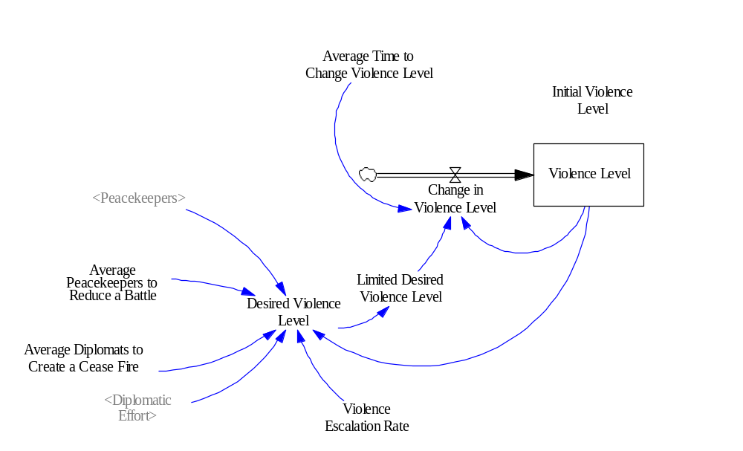
Violence Sub-Model

Peacekeepers
The level of peacekeepers is initially set to zero then has an flow called the change in peacekeepers which represents both an in-flow and a potential out-flow. The change in peacekeepers is simply the desired number of peacekeepers minus the current level of peacekeepers divided by the average time to deploy peacekeepers. The desired number of peacekeepers is simply the investment in peacekeeping divided by the average monthly cost of a peacekeeper.

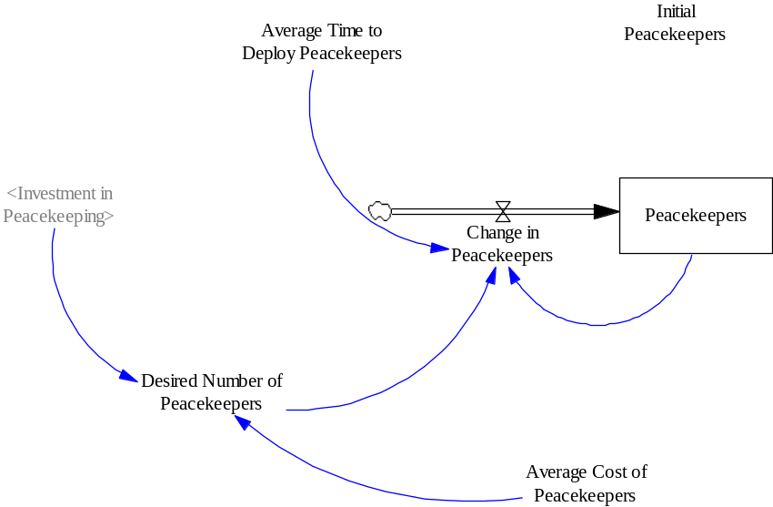
Peacekeepers Sub-Model
Diplomatic Effort
The level of diplomatic effort is initially set to zero then has an flow called the change in diplomatic effort which represents both an in-flow and a potential out-flow. The change in diplomatic effort is simply the desired amount of diplomatic effort minus the current level of diplomatic effort divided by the average time to employ diplomats. The desired amount of diplomatic effort is simply the investment in diplomacy divided by the average monthly cost of diplomatic effort.

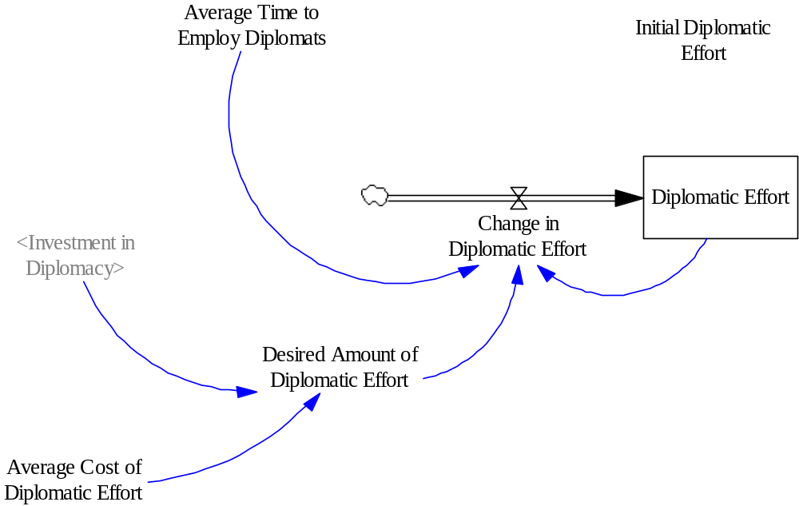
Diplomatic Effort Sub-Model

Health Services
The level of medical practitioners is initially set to zero then has an flow called the change in medical practitioners which represents both an in-flow and a potential out-flow. The change in medical practitioners is simply the desired number of medical practitioners minus the current level of medical practitioners divided by the average time to hire medical practitioners. The desired amount of medical practitioners is simply the investment in health services divided by the average monthly cost of a medical practitioner.

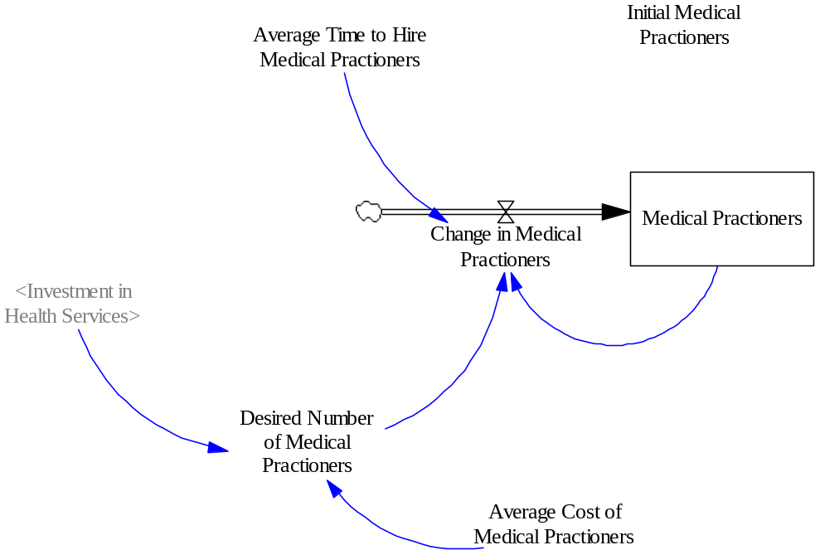
Health Services Sub-Model

Economic Activity
The economy sub-model has one stock variable, called businesses, which is initially set to a value so that the entire population of the foreign country has a job. Then the stock variable, businesses, changes based on the one in-flow (businesses created) and the one out-flow (businesses destroyed).

Businesses created is positive if the desired number of businesses is greater than the current number of businesses and is equal to the investment in economic development divided by the average cost of creating a business. Business destroyed is equal to the number of businesses divided by the time to destroy a business. The average time to destroy a business is equal to the normal time to destroy a business multiplied by the effect of violence on the time to destroy a business which, in turn, is based on the current level of violence divided by the normal level of violence required to destroy a business. The greater the relative violence level, the smaller the time to destroy a business.

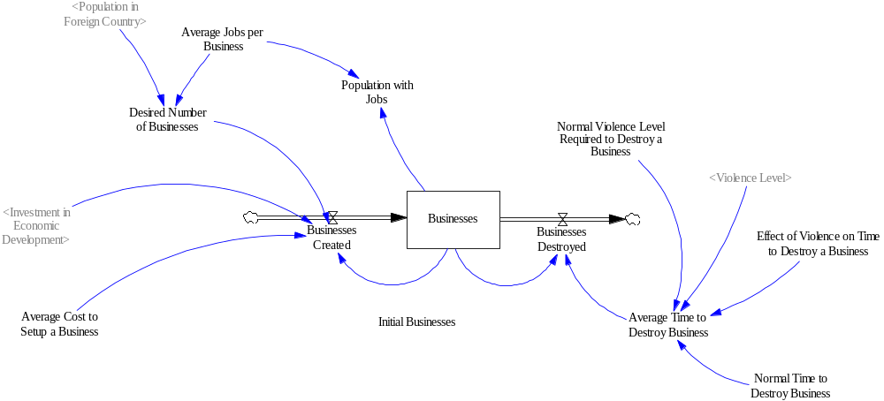
The Economy Sub-Model
Immigration
The level of immigration officers is initially set to zero then has an flow called the change in immigration officers which represents both an in-flow and a potential out-flow. The change in immigration officers is simply the desired number of immigration officers minus the current level of immigration officers divided by the average time to train immigration officers. The desired number of immigration officers is simply the investment in immigration divided by the average monthly cost of immigration officers.

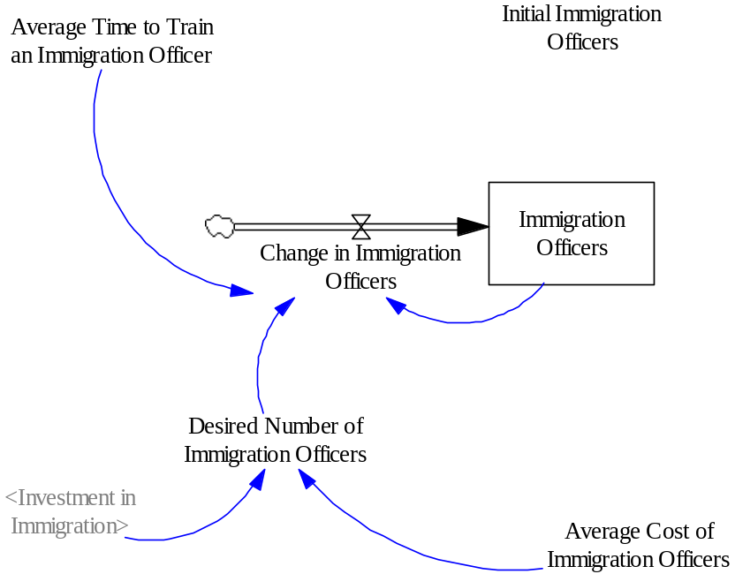
Immigration Officers Sub-Model

Border Crossing Resources
The level of border crossing resources is initially set to 100 boats then has an flow called the change in border crossing resources which represents both an in-flow and a potential out-flow. The change in border crossing resources is simply the desired number of border crossing resources minus the current level of border crossing resources divided by the average time to add border crossing resources. The desired number of border crossing resources is the normal border crossing resources times the effect of refugees on border crossings resources which in turn is based of the number of refugees divided by the normal number of refugees. The greater the relative number of refugees, the greater the increase in border crossing resources.
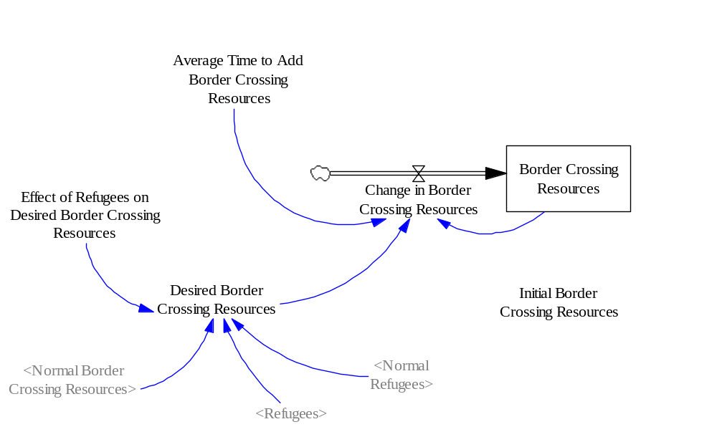
Border Crossing Resources Sub-Model

Border Control Resources
The level of border control resources is initially set to zero boats then has an flow called the change in border control resources which represents both an in-flow and a potential out-flow. The change in border control resources is simply the desired border control resources minus the current level of border control resources divided by the average time to deploy border control resources. The desired border control resources is the investment in border control divided by the average monthly cost of border control resources.

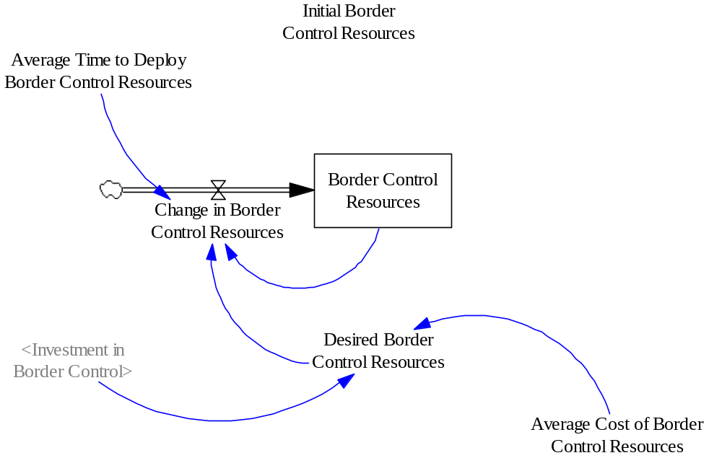
Border Control Resources Sub-Model

Unconventional Border Crossings
The unconventional border crossings sub-model consists of three stock variables: successful border crossings, unsuccessful border crossings and deaths from unsuccessful border crossings.

The central variable in this sub-model is attempted border crossings per month which is based on the normal attempted border crossings per month multiplied by a number of effects. The effect of border crossing resources on attempted border crossings is based on the current border crossing resources divided by the normal border crossing resources with the greater the relative amount of border crossing resources, the more attempted border crossings per month. The effect of refugees on attempted border crossings is based on the number of refugees divided by the normal number of refugees with the larger the relative number of refugees, the larger the number of attempted border crossings per month. The effect of border control on attempted border crossings is based on the current level of border control resources divided by the normal border control resources and, in this case, the greater the relative border control resources, the smaller the number of attempted border crossings per month. The effect of successful border crossings on attempted border crossings is based on the average number of successful border crossings per month divided by the normal number of successful border crossings per month, with a larger relative number of successful border crossings encouraging a greater number of attempted crossings per month. The effect of unsuccessful border crossings on attempted border crossings is based on the average number of unsuccessful border crossings per month divided by the normal number of unsuccessful border crossings per month. In this case, unsuccessful border crossings will discourage future border crossings. So, the greater the relative number of unsuccessful border crossings, the smaller the number of attempted border crossings per month.
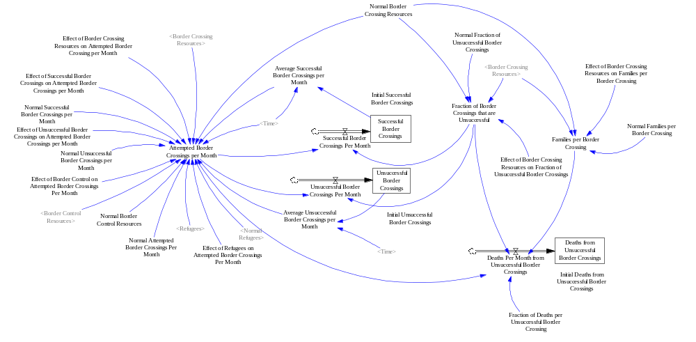
Unconventional Border Crossings Sub-Model
Unsuccessful Border Crossings
The stock variable unsuccessful border crossings has one in-flow, unsuccessful border crossings per month. The unsuccessful border crossings per month is calculated as the attempted border crossings per month multiplied the fraction of border crossings that are unsuccessful. The fraction of border crossings that are unsuccessful is calculated by multiplying the normal fraction of border crossings that are unsuccessful by the effect of border crossing resources on the fraction of border crossings that are unsuccessful which, in turn, is based on the current border crossing resources divided by the normal border crossing resources. In this case, the smaller the relative amount of border crossing resources, the more likely the border crossing will be unsuccessful.

Successful Border Crossings
The stock variable successful border crossings has one in-flow, successful border crossings per month. The successful border crossings per month is calculated as the attempted border crossings per month multiplied one minus the fraction of border crossings that are unsuccessful.

Deaths from Unsuccessful Border Crossings
The number of deaths from unsuccessful border crossings is one of the most visible aspects of the refugee crisis. The deaths per month from unsuccessful border crossings is the product of the attempted border crossings per month, the fraction of border crossings that are unsuccessful, the families per border crossing and the fraction of deaths per unsuccessful border crossing.

The families per border crossing is calculated multiplying the normal number of families per border crossing by the effect of border crossing resources on families per border crossing which, in turn, is based on the current border crossing resources divided by the normal border crossing resources. In this case, the smaller the border crossing resources, the larger the number of families per border crossing. That is, the boats are assumed to be more crowded.

Avoidable Deaths
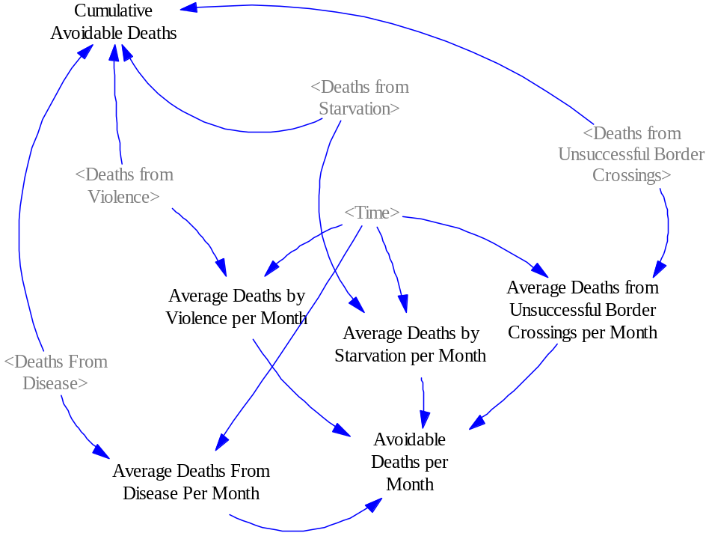
Avoidable Deaths Sub-Model

The final sub-model is called avoidable deaths. The avoidable deaths per month is calculated as the sum of the average deaths by violence per month, the average deaths by starvation per month, the average deaths from disease per month and average deaths from unsuccessful border crossings per month. These values, in turn, are based on the stock variables calculated in other sub-models (deaths from violence, deaths from starvation and deaths from disease in the refugee movement sub-model, and deaths from unsuccessful border crossings in the unconventional border crossings sub-model).

Also, the cumulative deaths is calculated as the sum of the deaths from violence, deaths from starvation, deaths from disease and deaths from unsuccessful border crossings.

Results from the Baseline Run
The constants, initial values and normal values (see Annex C) as well as the effect functions (see Annex B) have been estimated in a rough fashion to obtain a baseline run. One of the characteristics of System Dynamics modeling is the belief that it is better to provide a rough estimate of an important variable than to ignore the factor by leaving it out of the model. Thus using these rough estimates, the following graphs show the results of the baseline run.

In this first graph, it can be seen that the population in the foreign country starts at 10 million families and declines by two million families over the five year period. The population with enough food, the population without disease and the population in safe havens follows the pattern of the decline in the total population, however, is slightly lower than the total population which means that there are families at risk from violence, famine and disease. The greatest effect of the crisis is on the level of poverty in the country as the population with jobs drops off sharply in the first 30 months and eventually levels off at 4 million families which is roughly half of the population. Thus, it would seem that the bulk of the refugees are leaving the foreign country seeking greater economic opportunities.
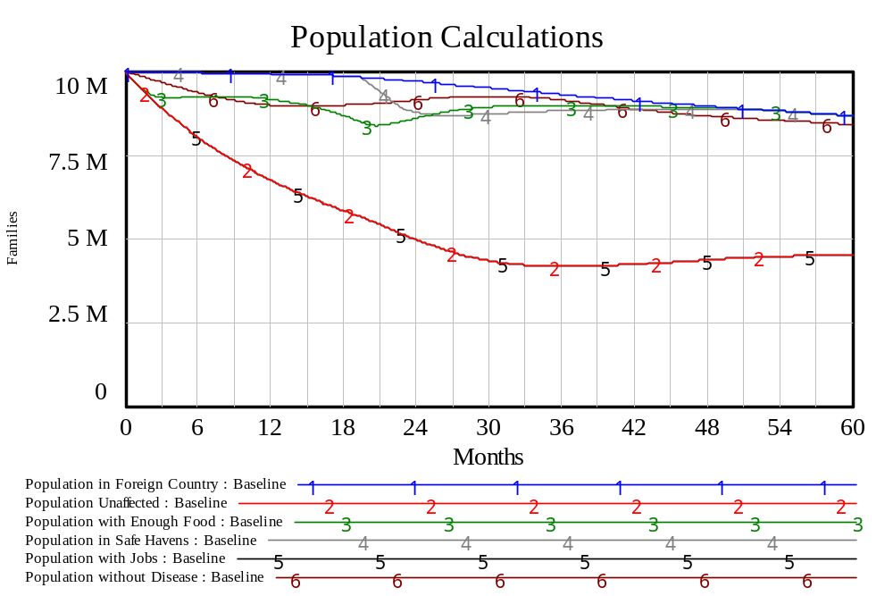

In the second graph, one can see the nature of the refugee crisis. The number of refugees increases quite a bit over the first two and a half years of the crisis, then declines as the immigration processes kick in and eventually appears to level off as the crisis is resolved. In the meantime, the refugees who have immigrated increases steadily over the five year period reaching over 80 thousand families.

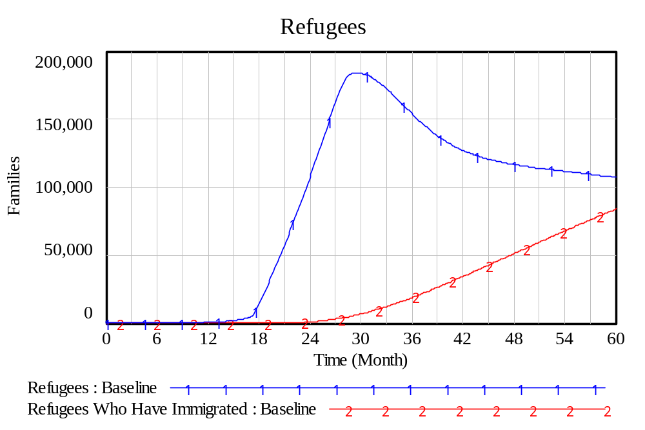

In the first months of the crisis, the number of avoidable deaths per month is dominated by deaths from starvation that begins to decline as food aid arrives (see graph below). The avoidable deaths caused by disease also increases quickly at the beginning but levels off after 18 months and declines slowly as the health practitioners are deployed. The avoidable deaths caused by violence increases quickly half way into the crisis but levels off and starts to decline after 36 months and declines slowly as the peacekeepers are deployed and the diplomatic effort starts to take effect. The avoidable deaths caused by unsuccessful border crossings is much smaller than the other avoidable deaths but seems to be increasing slightly throughout the period under examination.

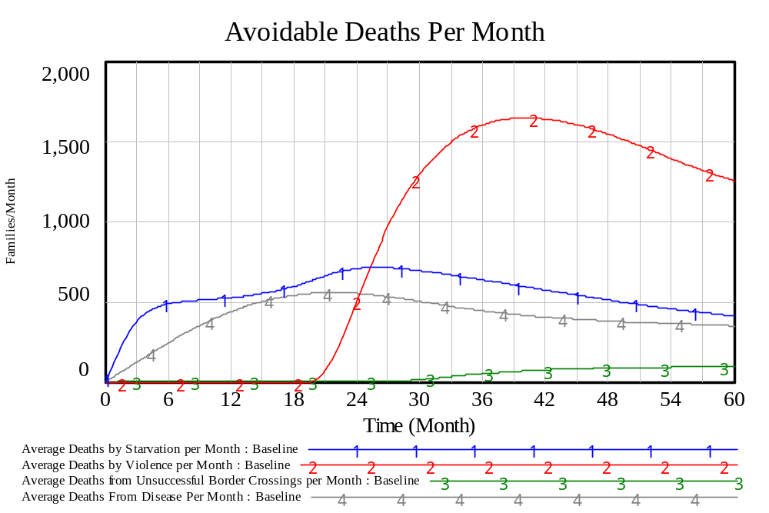
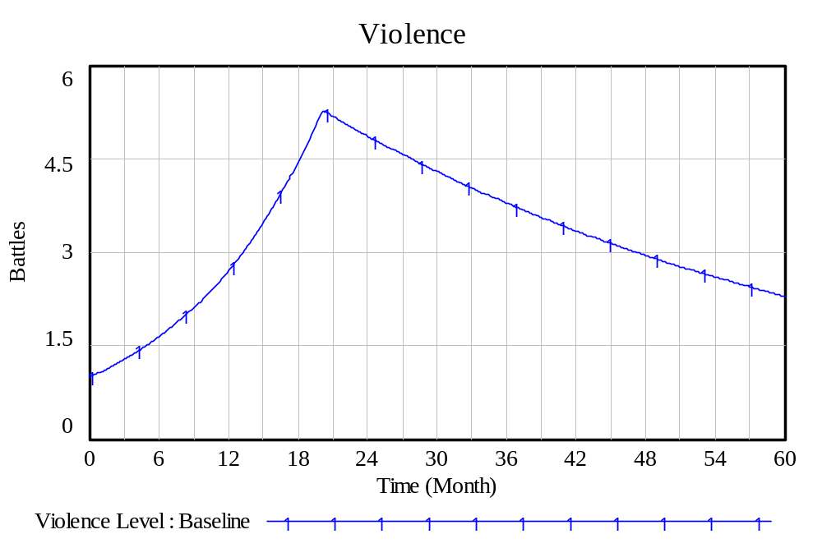
In the graph above, it can be seen that the level of violence increases rapidly in the first 18 months of the crisis. After that, the investment in peacekeeping and diplomacy starts to pay off and the level of violence begins to declines.

In the graph below, one can see that total investment increases rapidly but takes about 36 months to fully react to the crisis. It reaches a peak and then begins to decline.
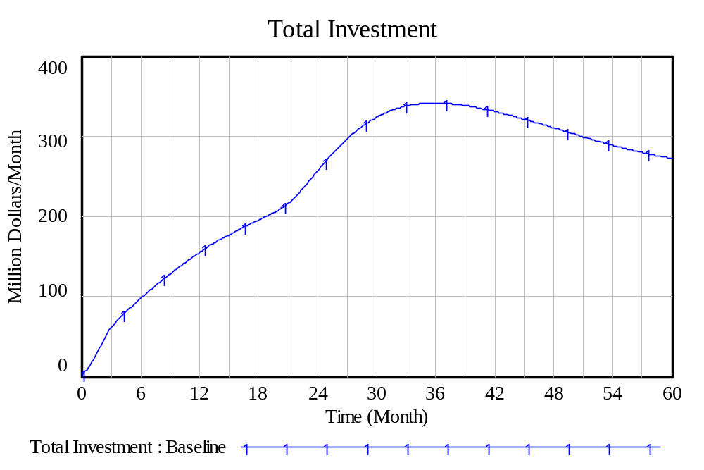

The graph below shows the allocation of investment between the various short-term forms of relief. Investment in food aid increases quickly, peaks and then begins to decline as the situation stabilizes. Investments in health services also increases quickly peaks and then declines. However, there appears to be the beginnings of an oscillation effect with health services. Investments in peacekeeping and diplomacy take about 18 months to get going and then rapidly increase, peak and decline to stabilize at a relatively low level. The investment in border control also takes a while to come into effect, then increases and stabilizes at a modest level.
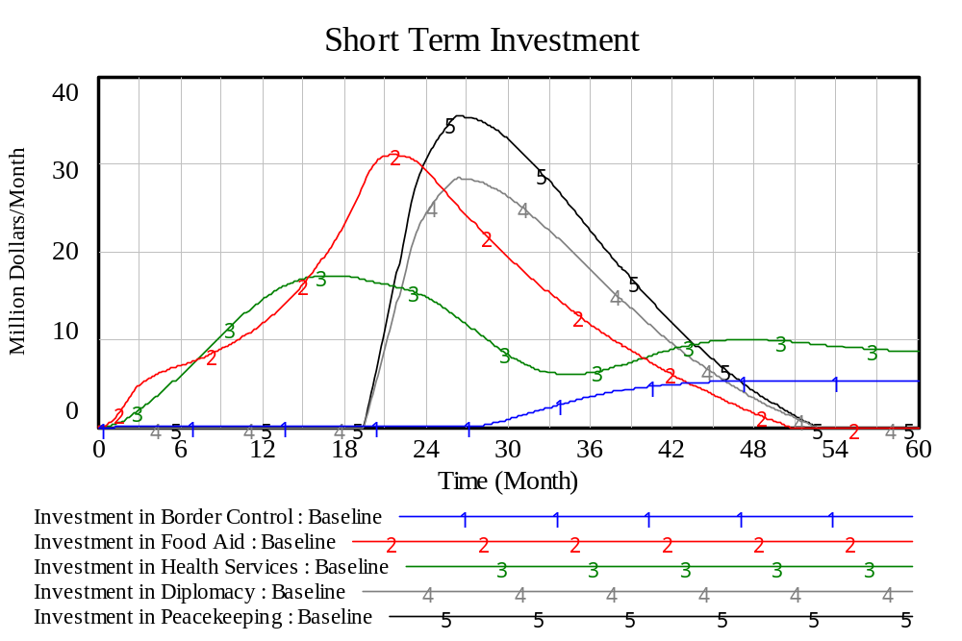

The economic development and immigration are long-term investments. In the graph below, it appears that immigration takes over two years to get started and then increases, peaks and levels off. The investment in economic development appears to have some oscillating effect. This relatively large amount of investment in economic development may be based on the fact that the population with jobs is the most affected by the crisis.

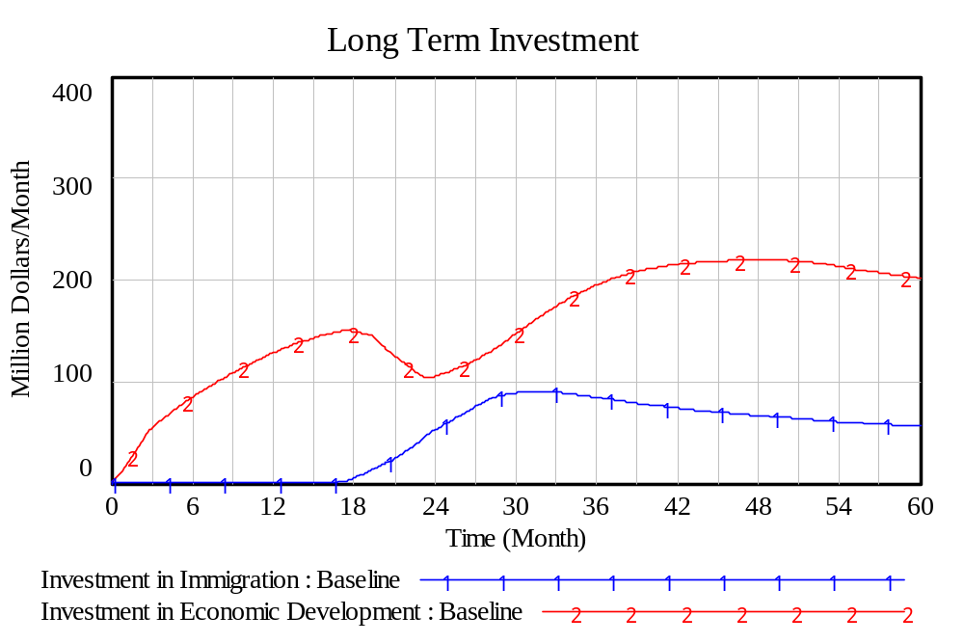

Next Steps
These results above can be, in no way, considered definitive since the constants, the normals and the effects are only estimated in a rough manner. Future work will examine the sensitivity of the results to these estimated values. An optimization of the model will also be attempted based on varying the parameters of the model that might be under control of the donor nations' decision makers.

The special purpose Vensim software package is very useful for building and testing a prototype model. The software has also provided a relatively easy way to visualize the System Dynamics model using stock and flow diagrams.

However, the Vensim software is somewhat unwieldy when it comes to conducting analysis when one wants to change a number of variables at once which is what is desired when a detailed sensitivity analysis is conducted or when an optimization process is used.

Therefore, the model will be converted into a more versatile general purpose programming language, namely Fortran. In Part 4 of this study, the Fortran version of the refugee crisis model will be documented. Then in Part 5, a detailed sensitivity analysis is conducted used a design of experiments technique. This is followed in Part 6 with an optimization of the model which uses a genetic algorithm to minimize the number of avoidable deaths.
ANNEX A
Equations in the System Dynamics Model of the Refugee Crisis

************************************************************************
0. Total Relief Money

Population in Safe Havens=IF THEN ELSE(Safe Havens*
Average Population per Safe Haven>=Population in Foreign Country,
Population in Foreign Country, Safe Havens*Average Population per Safe Haven)
Units: Families

Population with Enough Food=IF THEN ELSE((Food/
(Average Consumption per Family*Months))>=Population in Foreign Country, Population in Foreign Country, Food/(Average Consumption per Family*Months))
Units: Families

Population with Jobs= Businesses*Average Jobs per Business
Units: Families

Population without Disease=Population in Foreign Country-Population With Disease
Units: Families

Population Unaffected=MIN(Population with Enough Food,
MIN(Population without Disease, MIN(Population in Safe Havens,
Population with Jobs)))
Units: Families

Average Deaths by Starvation per Month=IF THEN ELSE(Time=0, 0,
Deaths from Starvation/Time)
Units: Families/Month

Average Deaths by Violence per Month=IF THEN ELSE(Time=0, 0,
Deaths from Violence/Time)
Units: Families/Month

Average Deaths From Disease Per Month=IF THEN ELSE(Time=0, 0,
Deaths From Disease/Time)
Units: Families/Month

Average Deaths from Unsuccessful Border Crossings per Month=
IF THEN ELSE(Time=0 , 0, Deaths from Unsuccessful Border Crossings/Time)
Units: Families/Month

Avoidable Deaths per Month=Average Deaths by Starvation per Month+
Average Deaths by Violence per Month+
Average Deaths from Unsuccessful Border Crossings per Month+
Average Deaths From Disease Per Month
Units: Families/Month

Total Investment=Normal Total Investment*
Effect of People in Danger on Total Investment(
(Population in Foreign Country-Population Unaffected)/
Population in Foreign Country)*
Effect of Deaths per Month on Total Investment(Avoidable Deaths per Month/
Normal Deaths per Month)
Units: Million Dollars/Month

************************************************************************
0.1 Allocation of Relief Money to Border Control

Fraction of Investment in Border Control=
Effect of Deaths per Month on Fraction of Investment in Border Control(
Average Deaths from Unsuccessful Border Crossings per Month
/Normal Deaths per Month From Unsuccessful Border Crossings)
Units: dmnl

Investment in Border Control=
Fraction of Investment in Border Control*Total Investment
Units: Million Dollars/Month

************************************************************************
0.2 Allocation of Relief Money to Food Aid

Desired Fraction of Investment in Food Aid=
Effect of Famine on Fraction of Investment in Food Aid(
(Population in Foreign Country-Population with Enough Food)/
Population in Foreign Country)
Units: dmnl

Fraction of Remaining Investment in Food Aid=MIN(
Desired Fraction of Investment in Food Aid, MAX(0,
(1-Fraction of Investment in Border Control)))
Units: dmnl

Investment in Food Aid=
Fraction of Remaining Investment in Food Aid*Total Investment
Units: Million Dollars/Month

************************************************************************
0.3 Allocation of Relief Money to Health Services

Desired Fraction of Investment in Health Resources=
Effect of Disease on Fraction of Investment in Health Resources(
(Population in Foreign Country-Population without Disease)/
Population in Foreign Country)
Units: dmnl

Fraction of Remaining Investment in Health Services=
MIN(Desired Fraction of Investment in Health Resources,
(1-Fraction of Investment in Border Control-
Fraction of Remaining Investment in Food Aid))
Units: dmnl

Investment in Health Services=
Fraction of Remaining Investment in Health Services*Total Investment
Units: Million Dollars/Month

************************************************************************
0.4 Allocation of Relief Money to Diplomacy

Desired Fraction of Investment in Diplomacy=
Effect of Violence on Fraction of Investment in Diplomacy(
(Population in Foreign Country-Population in Safe Havens)/
Population in Foreign Country)
Units: dmnl

Fraction of Remaining Investment in Diplomacy=
MIN(Desired Fraction of Investment in Diplomacy, MAX(0,
(1-Fraction of Investment in Border Control-
Fraction of Remaining Investment in Food Aid-
Fraction of Remaining Investment in Health Services)))
Units: dmnl

Investment in Diplomacy=
Fraction of Remaining Investment in Diplomacy*Total Investment
Units: Million Dollars/Month

************************************************************************
0.5 Allocation of Relief Money to Peacekeeping

Desired Fraction of Investment in Peacekeeping=
Effect of Violence on Fraction of Investment in Peacekeeping(
(Population in Foreign Country-Population in Safe Havens)/
Population in Foreign Country)
Units: dmnl

Fraction of Remaining Investment in Peacekeeping=
MIN(Desired Fraction of Investment in Peacekeeping,
MAX(0, (1-Fraction of Investment in Border Control-
Fraction of Remaining Investment in Food Aid-
Fraction of Remaining Investment in Health Services-
Fraction of Remaining Investment in Diplomacy)))
Units: dmnl

Investment in Peacekeeping=
Fraction of Remaining Investment in Peacekeeping*Total Investment
Units: Million Dollars/Month

************************************************************************
0.6 Allocation of Relief Money to Immigration

Desired Fraction of Investment in Immigration=
Effect of Refugees on Fraction of Investment in Immigration(
Refugees/Normal Refugees)
Units: dmnl

Fraction of Remaining Investment in Immigration=
MIN(Desired Fraction of Investment in Immigration, MAX(0,
(1-Fraction of Investment in Border Control-
Fraction of Remaining Investment in Food Aid-
Fraction of Remaining Investment in Health Services-
Fraction of Remaining Investment in Diplomacy-
Fraction of Remaining Investment in Peacekeeping)))
Units: dmnl

Investment in Immigration=
Fraction of Remaining Investment in Immigration*Total Investment
Units: Million Dollars/Month
************************************************************************
0.7 Allocation of Relief Money to Economic Development

Investment in Economic Development=
MAX(0, (Total Investment-Investment in Border Control-Investment in Food Aid-Investment in Health Services-Investment in Diplomacy- Investment in Peacekeeping Investment in Immigration))
Units: Million Dollars/Month

************************************************************************
1. Border Crossing Resources

Desired Border Crossing Resources=Normal Border Crossing Resources*
Effect of Refugees on Desired Border Crossing Resources(Refugees/Normal Refugees)
Units: Boats

Change in Border Crossing Resources=
(Desired Border Crossing Resources-Border Crossing Resources)/
Average Time to Add Border Crossing Resources
Units: Boats/Month

Border Crossing Resources= INTEG (Change in Border Crossing Resources,
Initial Border Crossing Resources)
Units: Boats
************************************************************************
2. Border Control Resources

Desired Border Control Resources=
Investment in Border Control/Average Cost of Border Control Resources
Units: Boats

Change in Border Control Resources=
(Desired Border Control Resources-Border Control Resources)/
Average Time to Deploy Border Control Resources
Units: Boats/Month

Border Control Resources= INTEG (Change in Border Control Resources,
Initial Border Control Resources)
Units: Boats

************************************************************************
3. Businesses

Desired Number of Businesses=
Population in Foreign Country/Average Jobs per Business
Units: Businesses

Businesses Created=
IF THEN ELSE(Desired Number of Businesses>Businesses,
Investment in Economic Development/Average Cost to Setup a Business , 0)
Units: Businesses/Month

Average Time to Destroy Business=
Normal Time to Destroy Business*
Effect of Violence on Time to Destroy a Business(Violence Level/
Normal Violence Level Required to Destroy a Business)
Units: Months

Businesses Destroyed=
Businesses/Average Time to Destroy Business
Units: Businesses/Month

Businesses= INTEG (Businesses Created-Businesses Destroyed,
Initial Businesses)
Units: Businesses

************************************************************************
2. Deaths From Disease

Death Rate From Disease=
Normal Death Rate From Disease*
(Population in Foreign Country-Population without Disease)
Units: Families/Month

Deaths From Disease= INTEG (Death Rate From Disease,
Initial Deaths From Disease)
Units: Families

************************************************************************
3. Deaths from Starvation

Death Rate from Starvation=
Normal Death Rate from Starvation*
(Population in Foreign Country-Population with Enough Food)
Units: Families/Month

Deaths from Starvation= INTEG (Death Rate from Starvation,
Initial Deaths from Starvation)
Units: Families
************************************************************************
4. Deaths from Violence

Death Rate from Violence=
Normal Death Rate from Violence*
(Population in Foreign Country-Population in Safe Havens)
Units: Families/Month

Deaths from Violence= INTEG (Death Rate from Violence,
Initial Deaths from Violence)
Units: Families

************************************************************************
5. Deaths from Unsuccessful Border Crossings

Average Successful Border Crossings Per Month=IF THEN ELSE(Time>1,
Successful Border Crossings/Time , 0)
Units: Border Crossings/Month

Average Unsuccessful Border Crossings Per Month=IF THEN ELSE(Time>1, Unsuccessful Border Crossings/Time , 0)
Units: Border Crossings/Month

Attempted Border Crossings per Month=IF THEN ELSE(Time=0, 0 ,
Normal Attempted Border Crossings Per Month*
Effect of Border Crossing Resources on Attempted Border Crossing per Month
(Border Crossing Resources/Normal Border Crossing Resources)*
Effect of Successful Border Crossings on Attempted Border Crossings per Month
(Average Successful Border Crossings Per Month/Normal Successful Border Crossings per Month)*
Effect of Unsuccessful Border Crossings on Attempted Border Crossings per Month
(Average Unsuccessful Border Crossings Per Month/Normal Unsuccessful Border Crossings per Month)*
Effect of Border Control on Attempted Border Crossings per Month
(Border Control Resources/Normal Border Control Resources)*
Effect of Refugees on Attempted Border Crossings Per Month
(Refugees/Normal Refugees))
Units: Border Crossings/Months

Families per Border Crossing=
Normal Families per Border Crossing*
Effect of Border Crossing Resources on Families per Border Crossing
(Border Crossing Resources/Normal Border Crossing Resources)
Units: Families/Border Crossings

Fraction of Border Crossings Will Be Unsuccessful=
Normal Fraction of Unsuccessful Border Crossings*
Effect of Border Crossing Resources on Fraction of Unsuccessful Border Crossings
(Border Crossing Resources/Normal Border Crossing Resources)
Units: dmnl

Deaths Per Month from Unsuccessful Border Crossings=
Attempted Border Crossings per Month*
Families per Border Crossing*
Fraction of Border Crossings Will Be Unsuccessful*
Fraction of Deaths per Unsuccessful Border Crossing
Units: Families/Month

Deaths from Unsuccessful Border Crossings= INTEG (
Deaths Per Month from Unsuccessful Border Crossings,
Initial Deaths from Unsuccessful Border Crossings)
Units: Families

Cumulative Avoidable Deaths=
Deaths From Disease+
Deaths from Starvation+
Deaths from Violence+
Deaths from Unsuccessful Border Crossings
Units: Families

************************************************************************6. Diplomatic Effort

Desired Amount of Diplomatic Effort=
Investment in Diplomacy/Average Cost of Diplomatic Effort
Units: Diplomats

Change in Diplomatic Effort=
(Desired Amount of Diplomatic Effort-Diplomatic Effort)/
Average Time to Employ Diplomats
Units: Diplomats/Month

Diplomatic Effort= INTEG (Change in Diplomatic Effort,
Initial Diplomatic Effort)
Units: Diplomats

************************************************************************7. Food

Food Aid=(Investment in Food Aid/Average Cost of Food Unit)*
Effect of Violence on Distribution of Food Aid
(Violence Level/Normal Violence Level Required to Disrupt Delivery of Food Aid)
Units: Food Units/Month

Food Consumption=(Food/Normal Food)*Average Consumption per Family*
Population in Foreign Country
Units: Food Units/Month

Famine=Effect of Violence on Famine(Violence Level/
Normal Violence Level Required to Destroy Harvest)
Units: dmnl

Food Growth Rate=Normal Food Growth Rate*(1-Famine)
Units: Food Units/Food Units/Month

Food Growth= MAX(0,Food Growth Rate*Food)
Units: Food Units/Month

Export Food=MAX(0, ((Food/Months)-
(Population in Foreign Country*Average Consumption per Family)))
Units: Food Units/Month

Food= INTEG (Food Aid+Food Growth-Export Food-Food Consumption,
Initial Food)
Units: Food Units

************************************************************************
8. Immigration Officers

Desired Number of Immigration Officers=
Investment in Immigration/Average Cost of Immigration Officers
Units: Immigration Officers

Change in Immigration Officers=
(Desired Number of Immigration Officers-Immigration Officers)/
Average Time to Train an Immigration Officer
Units: Immigration Officers/Month

Immigration Officers= INTEG (Change in Immigration Officers,
Initial Immigration Officers)
Units: Immigration Officers

***********************************************************************
9. Medical Practitioners

Desired Number of Medical Practitioners=
Investment in Health Services/Average Cost of Medical Practitioners
Units: Doctors

Change in Medical Practitioners=
(Desired Number of Medical Practitioners-Medical Practitioners)/
Average Time to Hire Medical Practitioners
Units: Doctors/Month

Medical Practitioners= INTEG (Change in Medical Practitioners,
Initial Medical Practitioners)
Units: Doctors

************************************************************************
10. Peacekeepers

Desired Number of Peacekeepers=
Investment in Peacekeeping/Average Cost of Peacekeepers
Units: Soldiers

Change in Peacekeepers=
(Desired Number of Peacekeepers-Peacekeepers)/
Average Time to Deploy Peacekeepers
Units: Soldiers/Month

Peacekeepers= INTEG (Change in Peacekeepers,
Initial Peacekeepers)
Units: Soldiers

************************************************************************11. Population in Foreign Country

Net Birth Rate=Normal Birth Rate*Population in Foreign Country-
Population in Foreign Country/Average Life Expectancy
Units: Families/Month

Average Time to Decide to Leave Foreign Country=
Normal Time to Decide to Leave Foreign Country*
Effect of People At Risk on Average Time to Decide to Leave Foreign Country
((Population in Foreign Country-Population Unaffected)/
Population in Foreign Country)
Units: Months

Net Additions to Refugees=
(Population in Foreign Country-Population Unaffected)/
Average Time to Decide to Leave Foreign Country
Units: Families/Month

Population in Foreign Country= INTEG (Net Birth Rate-Death Rate From Disease-
Death Rate from Starvation-Death Rate from Violence-Net Additions to Refugees,
Initial Population in Foreign Country)
Units: Families

************************************************************************
12. Population With Disease

Crowding Fraction=
Population in Safe Havens/Normal Families in Safe Havens
Units: dmnl

Infections Per Month=IF THEN ELSE(Population With Disease>0,
(Population in Safe Havens-Population With Disease)*Normal Infection Rate*
Effect of Crowding on Disease Rate(Crowding Fraction),0)
Units: Families/Month

Cured Per Month=IF THEN ELSE(Population With Disease>0,
Medical Practitioners*Average People a Medical Practitioner Can Handle/
Average Time to Cure Disease , 0)
Units: Families/Month

Population With Disease= INTEG (Infections Per Month-Cured Per Month,
Initial Population With Disease)
Units: Families

************************************************************************
13.. Refugees

Refugees Attempting Border Crossings=IF THEN ELSE(Refugees/Months<=
Attempted Border Crossings per Month*Families per Border Crossing,
Refugees/Months ,
Attempted Border Crossings per Month*Families per Border Crossing)
Units: Families/Month

Refugees Processed Per Month=Immigration Officers*
Families Processed At The Same Time By Immigration Officer/
Average Time to Process Immigration Papers
Units: Families/Month

Refugees= INTEG (Net Additions to Refugees-Refugees Attempting Border Crossings-Refugees Processed Per Month,
Initial Refugees)
Units: Families

************************************************************************
14.. Refugees Who Have Immigrated

Refugees Who Have Immigrated= INTEG (Refugees Processed Per Month,
Initial Refugees Who Have Immigrated)
Units: Families

************************************************************************
15. Safe Havens

Desired Number of Safe Havens=
Population in Foreign Country/Average Population per Safe Haven
Units: Havens

Average Time to Create Safe Haven=
Normal Time to Create a Safe Haven*
Effect of Peacekeepers on Time to Create Safe Haven
(Peacekeepers/Normal Peacekeepers Required to Protect Safe Haven)
Units: Months

Safe Havens Created=
(Desired Number of Safe Havens-Safe Havens)/Average Time to Create Safe Haven
Units: Havens/Month

Average Time to Destroy Safe Haven=
Normal Time to Destroy a Safe Haven*
Effect of Violence on Time to Destroy a Safe Haven
(Violence Level/Normal Violence Required to Destroy a Safe Haven)
Units: Months

Safe Havens Destroyed=Safe Havens/Average Time to Destroy Safe Haven
Units: Havens/Month

Safe Havens= INTEG (Safe Havens Created-Safe Havens Destroyed,
Initial Safe Havens)
Units: Havens

************************************************************************
16. Successful Border Crossings

Successful Border Crossings Per Month=
(1-Fraction of Border Crossings Will Be Unsuccessful)*
Attempted Border Crossings per Month
Units: Border Crossings/Month

Successful Border Crossings= INTEG (Successful Border Crossings Per Month,
Initial Successful Border Crossings)
Units: Border Crossings

************************************************************************
17. Unsuccessful Border Crossings

Unsuccessful Border Crossings Per Month=
Fraction of Border Crossings Will Be Unsuccessful*
Attempted Border Crossings per Month
Units: Border Crossings/Month

Unsuccessful Border Crossings= INTEG (Unsuccessful Border Crossings Per Month,
Initial Unsuccessful Border Crossings)
Units: Border Crossings

************************************************************************
18. Violence

Desired Violence Level=IF THEN ELSE(Violence Level<=0, 0,
(Violence Level*Violence Escalation Rate-
(Peacekeepers/Peacekeepers to Reduce a Battle+
Diplomatic Effort/Diplomats to Create a Cease Fire)))
Units: Battles

Limited Desired Violence Level=IF THEN ELSE(Desired Violence Level<=0, 0,
Desired Violence Level)
Units: Battles

Change in Violence Level=(Limited Desired Violence Level-Violence Level)/
Average Time to Change Violence Level
Units: Battles/Month

Violence Level= INTEG (Change in Violence Level,
Initial Violence Level)
Units: Battles

************************************************************************
ANNEX B
Effects Used in the Refugee Crisis Model

(01) Effect of Border Control on Attempted Border Crossings per Month
0 1
1 0.1
10 1e-005

(02) Effect of Border Crossing Resources on Attempted Border Crossing per Month
0 0
1 1
100 20

(03) Effect of Border Crossing Resources on Families per Border Crossing
0 10
1 1
100 1

(04) Effect of Border Crossing Resources on Fraction of Unsuccessful Border Crossings
0 5
1 1
100 0.01

(05) Effect of Crowding on Disease Rate
0 0
1 1
100000 10

(06) Effect of Deaths per Month on Fraction of Investment in Border Control
0 0
1 0.2
100 1

(07) Effect of Deaths per Month on Total Investment
0 1
1 2
100 50

(08) Effect of Disease on Fraction of Investment in Health Resources
0 0
0.2 0.2
1 1

(09) Effect of Famine on Fraction of Investment in Food Aid
0 0
0.2 0.2
1 1

(10) Effect of Peacekeepers on Time to Create Safe Haven
0 1000
1 1
100 0.01

(11) Effect of People At Risk on Average Time to Decide to Leave Foreign Country
0 100
0.4 0.5
1 0

(12) Effect of People in Danger on Total Investment
0 0
0.1 2
1 10

(13) Effect of Refugees on Attempted Border Crossings Per Month
0 0
1 1
100 100

(14) Effect of Refugees on Desired Border Crossing Resources
0 0
1 1
100 100

(15) Effect of Refugees on Fraction of Investment in Immigration
0 0
10 0.2
100 1

(16) Effect of Successful Border Crossings on Attempted Border Crossings per Month
0 0
1 1
1000 50

(17) Effect of Unsuccessful Border Crossings on Attempted Border Crossings per Month
0 1
1 0.01
100 0.001

(18) Effect of Violence on Distribution of Food Aid
0 1
1 0.5
10 0.1

(19) Effect of Violence on Famine
0 0
1 0.2
10 1

(20) Effect of Violence on Fraction of Investment in Diplomacy
0 0
0.2 0.2
1 1

(21) Effect of Violence on Fraction of Investment in Peacekeeping
0 0
0.4 0.5
1 1

(22) Effect of Violence on Time to Destroy a Business
0 100
1 1
20 0.2

(23) Effect of Violence on Time to Destroy a Safe Haven
0 100
1 1
2 0.01

ANNEX C
Constants for the Refugee Crisis Model

CONSTANTS
(01) Average Consumption per Family=
1
Units: Food Units/Month/Families

(02) Average Cost of Border Control Resources=
1
Units: Million Dollars/Boats/Month

(03) Average Cost of Diplomatic Effort=
0.001
Units: Million Dollars/Diplomats/Month

(04) Average Cost of Food Unit=
1e-005
Units: Million Dollars/Food Units

(05) Average Cost of Immigration Officers=
0.01
Units: Million Dollars/Immigration Officers/Month

(06) Average Cost of Medical Practitioners=
0.005
Units: Million Dollars/Doctors/Month

(07) Average Cost of Peacekeepers=
0.01
Units: Million Dollars/Soldiers/Month

(08) Average Cost to Setup a Business=
0.01
Units: Million Dollars/Businesses

(09) Average Diplomats to Create a Cease Fire=
10
Units: Diplomats/Battles

(10) Average Jobs per Business=
10
Units: Families/Businesses

(11) Average Life Expectancy=
600
Units: Months

(12) Average Peacekeepers to Reduce a Battle=
1000
Units: Soldiers/Battles

(13) Average People a Medical Practitioner Can Handle=
100
Units: Families/Doctors

(14) Average Population per Safe Haven=
50000
Units: Families/Havens

(15) Average Time to Add Border Crossing Resources=
12
Units: Months

(16) Average Time to Change Violence Level=
48
Units: Months

(17) Average Time to Cure Disease=
2
Units: Months

(18) Average Time to Deploy Border Control Resources=
6
Units: Months

(19) Average Time to Deploy Peacekeepers=
12
Units: Months

(20) Average Time to Employ Diplomats=
6
Units: Months

(21) Average Time to Hire Medical Practitioners=
6
Units: Months

(22) Average Time to Process Immigration Papers=
12
Units: Months

(23) Average Time to Train an Immigration Officer=
12
Units: Months

(24) Boat Months per Border Crossing=
0.5
Units: (Boats*Months)/Border Crossings

(25) Families Processed At The Same Time By Immigration Officer=
5
Units: Families/Immigration Officers

(26) Fraction of Deaths per Unsuccessful Border Crossing=
1
Units: dmnl

(27) Violence Escalation Rate=
5
Units: dmnl

INITIALS

(01) Initial Border Control Resources=
0
Units: Boats

(02) Initial Border Crossing Resources=
100
Units: Boats

(03) Initial Businesses=
1e+006
Units: Businesses

(04) Initial Deaths From Disease=
0
Units: Families

(05) Initial Deaths from Starvation=
0
Units: Families

(06) Initial Deaths from Unsuccessful Border Crossings=
0
Units: Families

(07) Initial Deaths from Violence=
0
Units: Families

(08) Initial Diplomatic Effort=
0
Units: Diplomats

(09) Initial Food=
1e+007
Units: Food Units

(10) Initial Immigration Officers=
0
Units: Immigration Officers

(11) Initial Medical Practitioners=
50
Units: Doctors

(12) Initial Peacekeepers=
0
Units: Soldiers

(13) Initial Population in Foreign Country=
1e+007
Units: Families

(14) Initial Population With Disease=
1000
Units: Families

(15) Initial Refugees=
0
Units: Families

(16) Initial Refugees Who Have Immigrated=
0
Units: Families

(17) Initial Safe Havens=
200
Units: Havens

(18) Initial Successful Border Crossings=
1
Units: Border Crossings

(19) Initial Unsuccessful Border Crossings=
1
Units: Border Crossings

(20) Initial Violence Level=
1
Units: Battles

NORMALS
(01) Normal Attempted Border Crossings Per Month=
10
Units: Border Crossings/Months

(02) Normal Birth Rate=
0.001
Units: Families/Families/Month

(03) Normal Border Control Resources=
10
Units: Boats

(04) Normal Border Crossing Resources=
100
Units: Boats

(05) Normal Death Rate From Disease=
0.0008
Units: Families/Families/Month

(06) Normal Death Rate from Starvation=
0.0008
Units: Families/Families/Month

(07) Normal Death Rate from Violence=
0.005
Units: Families/Families/Month

(08) Normal Deaths per Month=
1000
Units: Families/Month

(09) Normal Deaths per Month From Unsuccessful Border Crossings=
1000
Units: Families/Month

(10) Normal Families in Safe Havens=
10000
Units: Families

(11) Normal Families per Border Crossing=
50
Units: Families/Border Crossings

(12) Normal Food=
1e+007
Units: Food Units

(13) Normal Food Growth Rate=
1
Units: Food Units/Food Units/Month

(14) Normal Fraction of Unsuccessful Border Crossings=
0.01
Units: dmnl

(15) Normal Infection Rate=
0.01
Units: Families/Families/Month

(16) Normal Peacekeepers Required to Protect Safe Haven=
1000
Units: Soldiers

(17) Normal Refugees=
10000
Units: Families

(18) Normal Successful Border Crossings per Month=
10
Units: Border Crossings/Month

(19) Normal Time to Create a Safe Haven=
24
Units: Months

(20) Normal Time to Decide to Leave Foreign Country=
600
Units: Months

(21) Normal Time to Destroy a Safe Haven=
36
Units: Months

(22) Normal Time to Destroy Business=
24
Units: Months

(23) Normal Total Investment=
20
Units: Million Dollars/Month

(24) Normal Unsuccessful Border Crossings per Month=
10
Units: Border Crossings/Month

(25) Normal Violence Level Required to Destroy a Business=
1
Units: Battles

(26) Normal Violence Level Required to Destroy Harvest=
5
Units: Battles

(27) Normal Violence Required to Destroy a Safe Haven=
5
Units: Battles

(28) Normal Violence Required to Disrupt Delivery of Food Aid=
5
Units: Battles

